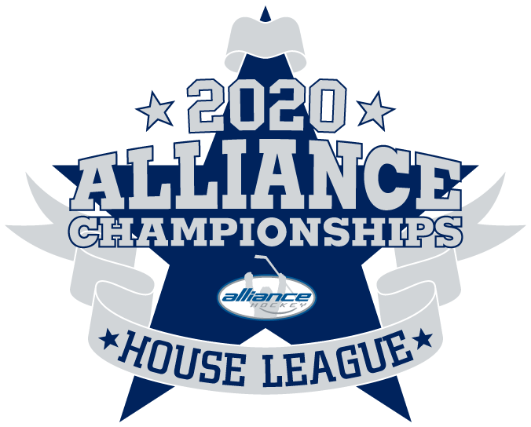

2020 ALLIANCE Hockey House League Championships – Rules
- Hockey Canada rules will apply. The Championship Chair has final say on all tournament rules, regulations and protests.

- The OHF suspension list will be used to assess all major, Misconduct and Match Penalties. The Tournament Chair may add to the suspension, if appropriate. If a player or coach receives a suspension during the tournament, the team must check with the Tournament to confirm the number of games to be served. Any player receiving a fighting major will be suspended for the duration of the Championships.

- The Championship Committee reserves the right to make any or all decisions.

- Teams are required to provide the Championship Office with their roster and travel permit prior to their first game. All teams will be limited to a maximum of 19 players. Teams are allowed a maximum of 5 Team Officials on the bench. The home team is designated by the tournament schedule. The home team wears dark jerseys. In the case of conflicting jerseys, the home team will change.

- Affiliated players (AP’s) are not permitted with the exception of Goaltenders.

- Teams shall be prepared to play 15 minutes ahead of scheduled start times.

- No one is allowed on the ice until the ice surfacing machine has left the ice and the doors are closed. Upon conclusion of each game, players will meet at center ice and shake hands, unless the referee(s) determines it is inadvisable to do so for reasons of players safety, etc.

- Dressing rooms are to be vacated promptly after the game has been completed. Arena staff will inspect the room prior to the next team entering. Keys for the dressing rooms are available in the Championship Office located in the Red rink.

- There will be a 3-minute warm up prior to the start of each game.

- Games at Novice, Atom and Peewee will be 10-10-F-10 and games at Bantam 10-10-F-15 and Midget, Juvenile will be 10- 15-F-15. No time outs are allowed in preliminary round. One(1) time out per team is allowed in Semi-Final and Final games. Floods will occur between the 2nd and 3rd periods, not at the end of the game.

- Championship Mercy Rule: Applies to the 3rd period when the difference in score is five (5) goals or more (If the difference becomes less than five (5) the clock still runs straight time). Mercy Rule will not apply to Quarter Final, Semi-Final and Final Games.
Penalties During Mercy Rule:
.1 All penalties called when mercy rule is in effect are time and a half
Example: 2 minutes is 3, 4 minutes is 6, 5 minutes is 7:30 and 10 minutes is 15.
.2 A penalty cannot be completed during a stoppage of play. The player may not leave
the penalty box until the puck is dropped.
.3 Any penalties called before the mercy rule goes into effect shall remain as called.
Example: A 2 minute penalty called with 30 seconds left in the 2nd period, with the score 5-0.
The remaining time in the penalty will be 1 minute and 30 seconds at the start of the 3rd period.
- Overtime Rule: At the end of regulation time where the game is tied, a 3 on 3, 5 minute sudden victory overtime period will be played. In the event the game is still tied at the conclusion
of the 5 minute overtime period, the teams will commence with another 5 minute 3 on3 until there is a winner.

- Points will be awarded as follows: Three(3) points for a win, two(2) points for an overtime win, one(1) point for an overtime loss and zero(0) points for a loss.

- If teams are tied at end of round robin play, the final standings will be determined using the ALLIANCE Hockey tie breaking rule found in the Manual of Operations.

- In the event of inclement weather, games cannot be cancelled or rescheduled. There will not be any repercussions levied against players/teams who in their best judgement cannot travel to games, but games will be recorded as a 5-0 forfeit as per Hockey Canada rules. In the event of both teams not attending a game, both teams will receive a 5-0 forfeit.

- The Championship Committee will not be responsible for any injuries incurred during the Tournament. All precautions will be taken to protect participants.

- There are no appeals. All decisions of the Championship Committee and referee(s) are final.

